PROJECT DOCUMENTATION

# Employee Management

Revision History

|  |  |  |  |
| --- | --- | --- | --- |
| Version No. | Date | Prepared by / Modified by | Significant Changes |
|  |  |  |  |
|  |  |  |  |

Glossary

|  |  |
| --- | --- |
| Abbreviation | Description |
| DB | Database |
| DDB | Distributed Database |
| ER | Entity Relationship |

Table of Contents

1.Project Brief...................................................................................

1.1. Purpose

1.2. Project Objective

1.3. Project Scope

2.Approvals..........................................................................

3. 3 Design and Detailed technical update

3.1. Process model

3.1.1 Use case Model

# Project Brief

## Purpose

The documents provide information of the project.

The project Initiation Document (PID), contains further explanation regarding the ongoing project.

Purpose of the project is to create a “Employee Management System” which sorts the administrators.

  Administrators are allowed to search and insert edit update Employees Details.

## Project Objective

Employee Management is now getting crucial.

For small businesses this may Cost them plenty.

To make cost effective and User friendly. We came up with this.

## Project Scope

They include administrative functions.

This can be used by anyone with required technology.

# Approvals

This document requires the following approvals.

Signed approval forms are filed in the Management section of the project files.

|  |  |  |  |  |
| --- | --- | --- | --- | --- |
| **Name** | **Signature** | **Title** | **Date of Issue** | **Version** |
|  |  |  |  |  |
|  |  |  |  |  |

**__________________________________________________________________**

**2.4      Distribution**

This document has been distributed to:

|  |  |  |  |  |
| --- | --- | --- | --- | --- |
| **Name** | **Title** | **Sap ID** | **Date of Issue** | **Version** |
| Palle Sai Laxmana Vignesh |  | 51965524 |  |  |
| Boddula Pranay Kumar |  | 51969606 |  |  |
| Ajay Kumar Mahto |  | 51965055 |  |  |
| Sai Sudhamsh |  | 51971192 |  |  |
| Moturi Srija |  | 51971177 |  |  |
| Akkaram Pradeepa |  | 51971255 |  |  |

# Design and Detailed technical updates

<Provide details of the Design/approach for developing/implementing the requirements>

## Process model

### Use case Model

### Sequence diagram

|  |  |
| --- | --- |
| Brief Description | User Registration |
| Basic Flow | This use case describes how a client register in to the system   1. The client has to register himself into the system. 2. After the successful registration, client will get a success message. 3. The following information is required during registration.  * Name * Address * Email * Mobile Number |
| Alternate Flow | 1. The system will validate the information provided. If any invalid data is found, the input form will be redirected with error message. |
| Validation | 1. Name is required and can’t be empty. 2. Address can’t be empty. 3. The Email should be valid. 4. Account details should be valid. |
| Pre-Conditions | User should have network access and Browser with latest updates. |
| Post-Conditions | Success message should be shown. |

## Database design

## Tables

Tables used

Employee Table

|  |  |  |  |
| --- | --- | --- | --- |
| NAME OF FIELD | TYPE | SIZE | Description |
| E_id | number | 12 | Primary key |
| E_username | Varchar2 | 50 | Not null, unique |
| E_password | Varchar2 | 20 | Not null |
| E_description | Varchar2 | 200 |  |

## Entity-Relationship Diagram

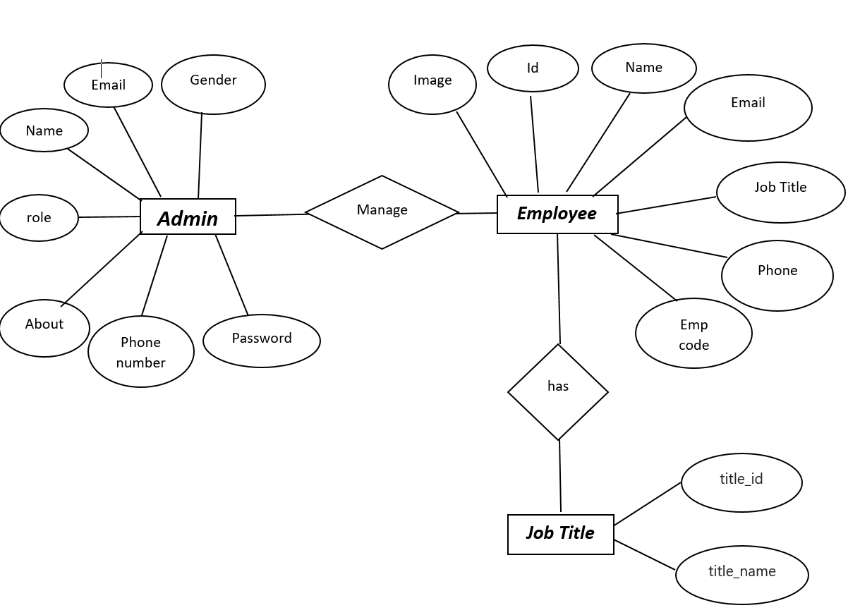

## Activity Diagram

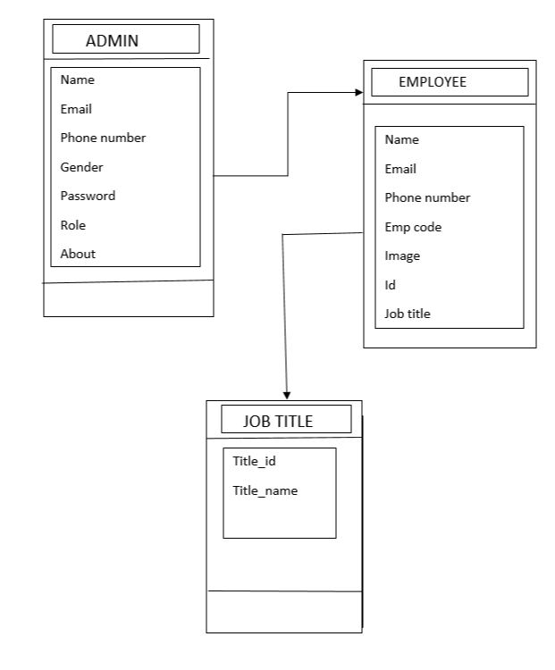

# Details of Alternative Design Approach

## Flow Chart

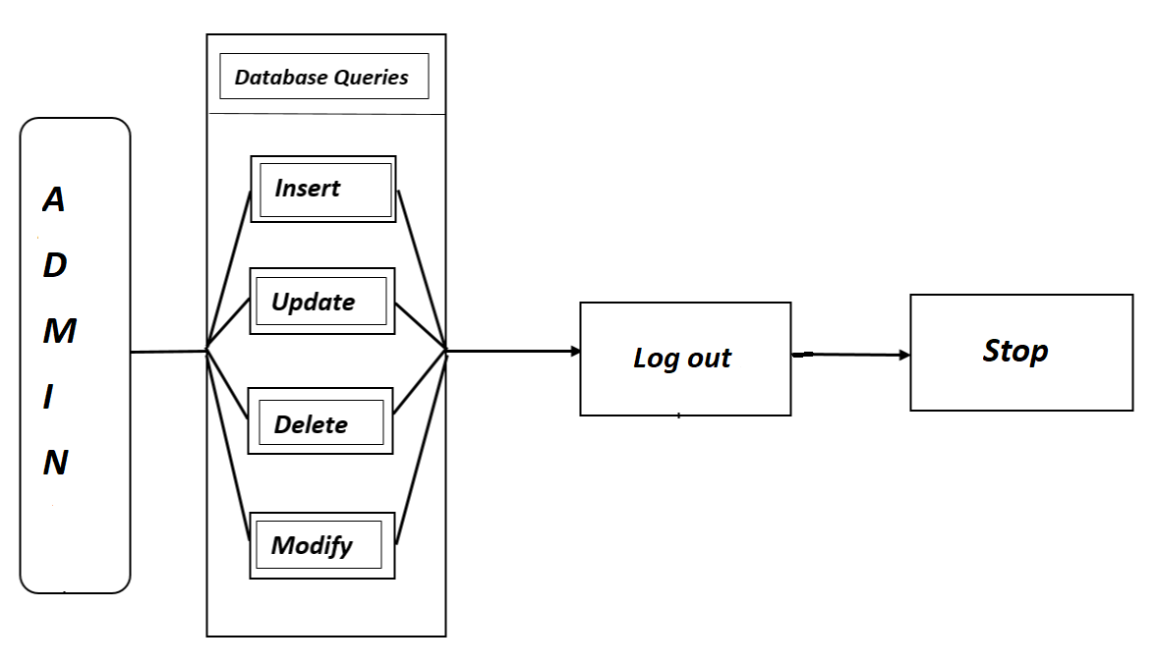

### Admin Flow Chart



# Other Technical Implementations

**Logical View**

**Technology/ Framework**

**Layer**

UI Components

Angular

Presentation Layer

Add

delete

Search

Update

Web-Server Classes

Java 1.8/ Spring

Boot

Application/ Business Layer

Controllers

Configuration

REST Controllers

Service

Entity/ Model Classes

Data Access Layer

Spring JPA

Repository classes

Oracle 11g Database

## CI / Build relates tasks

## Non-functional related changes

# Additional details

## Software Requirements

* Windows version 7+.
* A browser which supports CGI, HTML & JavaScript.
* Front-end software: Angular
* Back-end software: Oracle Database

## Non Functional Requirements

* **AVAILABILITY:** The flight should be available on the specified date and specified time as Admin may need it any time.
* **CORRECTNESS:** Correct data should be displayed.
* **MAINTAINABILITY:** The administrators should maintain correct data.
* **USABILITY:** Can be used by Admin.

# References